Practical - 10
Practical Title: Secure Login/Logout with Sessions, Role-Based Access, Timeout, and Remember-Me Token
Problem Definition: Develop secure login and logout functionality using PHP sessions. Verify password using password_verify(), regenerate session ID after login, restrict dashboard access, implement role-based redirection, session timeout, and optional secure remember-me token.
Theory:
- Are sessions started and destroyed securely?
Ans: Yes, sessions are initiated using session_start() and protected with session_regenerate_id(true) upon login, then completely cleared using session_unset(), session_destroy(), and expired cookies on logout.
- Is password_verify() used correctly?
Ans: Yes, password_verify() compares the user-submitted plaintext password directly against the stored hash retrieved from the database to securely authenticate credentials.
- Is unauthorized dashboard access blocked?
Ans: Yes, protected dashboard pages verify session variables via an authentication check, immediately redirecting unauthenticated users to the login page.
- Is session timeout implemented?
Ans: Yes, an inactivity timer tracks $_SESSION['LAST_ACTIVITY'] and automatically destroys the session if idle time exceeds the designated timeout limit.
- Are admin and student users redirected to appropriate dashboards?
Ans: Yes, the login logic inspects the user's role column and routes admin users to the Admin Panel and student users to the Student Dashboard.
Implementation/ Output/Result :
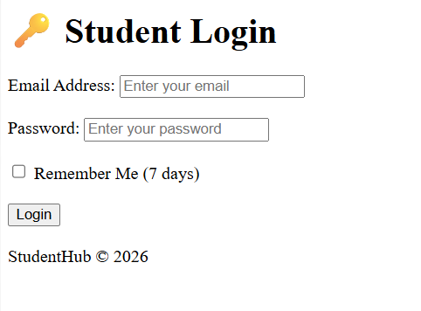
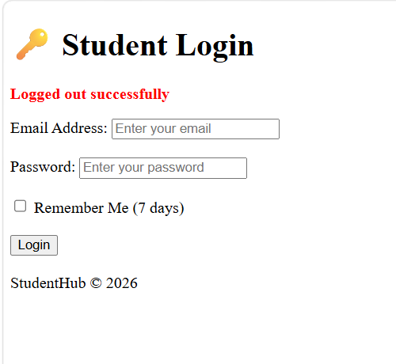
- GitHub Repository Link:
StudentHub/session at main · savaliyariya03/StudentHub
- Challenges Faced:
I faced challenges in security and session understanding.
- Learning Outcomes:
Now I understand how to secure data and how to set session.
- Faculty Remarks:

